Contents
1. Overview 2
2. DISCLAIMER 2
3. Starting EDM930/960 Configuration Editor 2
4. Changing Gauge Layout 4
5. Removing Fuel Level Gauges from display 4
6. Replacing Gauges 5
7. Changing Gauge Markings 6
8. Gauge Details Screen 7
9. Gauge Range and Alarm Limits 8
10. Color Bands 8
11. Options 9
12. Modifying Aircraft Information 9
13. Changing Tail Number 10
14. Change Number of Engine Cylinders 10
15. Changing fuel units 11
16. Changing Main Tank Size 11
17. Changing Channels Monitored 12
18. Changing Alarm Values 13
19. EDM Alarms Screen 13
20. Restoring EDM to a Previous Configuration 14
21. Restoring EDM to Factory Configuration 14

1. Overview
This program assists you in configuring the EDM-930 SINGLE and EDM-960 TWIN unit. In this guide they will all be called EDM. The EDM has numerous parameters that control the operation of the unit. All non-primary user parameters can be modified either by (1) using the four-button interface on the front panel of the EDM or (2) by using EDM Configuration Editor—described here—that provides a windows based utility that facilitates modifying these various parameters in a user-friendly way. Note: appearances may vary due to different revisions and instrument configurations.
EDM’s approved as primary instruments have preset alarm limits and do not allow changing of these primary alarm limits and cautionary ranges for the following measurements: oil temperature, oil pressure, fuel pressure (Optional in some aircraft), fuel quantity, cylinder head temperature, turbine inlet temperature, manifold pressure, and RPM. Other non-primary parameters may be changed by the user.

2. DISCLAIMER
Proper configuration of your J.P. Instruments EDM is very important to the safe operation of your aircraft. All primary instrument settings must conform to the manufacturer's limitations for your aircraft.
It is your responsibility to ensure that all limitations and markings are correct before operating your aircraft.
By continuing to run the EDM Configuration Editor, you acknowledge:
  - You have read the Pilot's Guide for this device
  - You have read the EDM Configuration Guide
  - You will not use this program for any purpose other than configuration of your J.P. Instruments EDM system.
  - Your agreement with this information.

3. Starting EDM930/960 Configuration Editor
All EDM930 and EDM960 units manufactured or updated after Sep 14, 2012 have the EDM Configuration Editor built into a separate utility memory area of the EDM.
To start the EDM Configuration Editor, hold the left two EDM buttons (STEP & LF) while powering up the EDM. This will start the EDM in a special AppLoader mode. Once the EDM Configuration Editor program is found, a button will be labeled CFG EDITOR. Press the button to run the EDM Configuration Editor program.
When EDM Configuration Editor starts, it will show a startup screen titled EDM960 Configuration Editor or EDM930 Configuration Editor that lists the version information for the Editor.
USB Configuration Capturing- Captures all your settings except fuel tables and keeps them for later use. You may insert a clean USB thumb drive any time during use of the program Config Editor. STEP through all the levels offered until End Config Edits and insert the USB thumb drive. Hit SAVE and the configuration will be downloaded and time stamped to the thumb drive. When making changes to anything while using Config Editor install the thumb drive before saving and it will save the previous configuration and time stamp
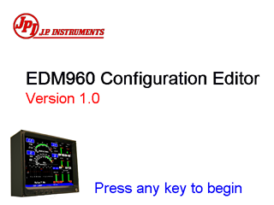

4. Changing Gauge Layout
Positions of non-primary linear strip gauges can be exchanged with other non-primary gauges on the right half of the display. When you see the EDIT GAUGE LAYOUT? prompt, tap the YES key to allow selection of gauges to be repositioned on the EDM screen.
Tap the NEXT key to select the strip gauge to be moved. If you go past the desired strip gauge, Tap the PREV key to go back to the previous gauge.
Tap the SELECT key to start repositioning of the gauge on the EDM.
After a gauge is selected, tap the NEXT key to select the new position for gauge to be moved. When the correct location has been selected, tap the MOVE key. When all desired gauge location changes have been made, tap the DONE key to exit this screen. If you get an extended “Loading…” comment on the display just hit STEP or NEXT.
Notes: If the EDM is configured as a PRIMARY instrument, PRIMARY gauges cannot be moved and will be skipped.
The EDM screen must contain at least 2 non-primary gauges in order to allow repositioning of gauges.
Editing of Gauge Layout requires EDM software version 1.20.464 or later.

5. Removing Fuel Level Gauges from display
If you prefer to use the ship’s fuel level gauges, you can choose to remove the fuel level gauges from the EDM display. When you see the EDIT GAUGE LAYOUT? prompt, tap the YES key to allow selection of the fuel level gauges to be removed from the EDM screen.
Tap the NEXT key to select the fuel level strip gauge to be removed.
Tap the REMOVE key to remove the fuel level gauge from the EDM. Both fuel level gauges will be removed.
If you want to re-enable fuel level gauges on the EDM, tap NEXT key until the fuel level gauge location is selected. Tap the ADD key to restore the fuel level gauges to the EDM display. Tap the DONE key to exit this screen.

6. Replacing Gauges
You can select the information to be displayed on any non-primary linear strip gauge. For example, you may want to replace OAT with CDT or CARB temperature gauges. . When you see the EDIT GAUGES? prompt, tap the YES key to allow selection of gauges to be replaced with another gauge on the EDM screen.
Tap the NEXT key to select the strip gauge to be replaced or Tap the PREV key to select the previous gauge.
Tap the MODIFY key to start editing of the selected gauge.

Tap the Next key until the gauge name is highlighted (box around gauge name). Tap the MODIFY key to start selection of a new input channel to be displayed on this gauge. Tap the YES key if you want to change the gauge name. Tap the NEXT key until the desired gauge name is selected. When you have selected the desired gauge, tap the SAVE key to replace the original gauge with the new gauge. Tap the YES key if you want to make the change. After the new gauge is displayed, you will want to tap the MODIFY key to set the gauge markings and limits for your aircraft. See the “Changing Gauge Markings” section below.
Note: If the EDM is configured as a PRIMARY instrument, PRIMARY gauges cannot be removed or replaced.
Replacing gauges requires EDM application version 1.20.489 or later.

7. Changing Gauge Markings
When you see the EDIT GAUGES? prompt, tap the YES key to allow selection of gauges to be modified on the EDM screen.
Tap the NEXT key to select the next gauge to be modified. Hold the NEXT key to select the previous gauge.
Tap the MODIFY key to start modification of the gauge on the EDM. Use the NEXT key to navigate through each position on the gauge to change color or limit markings.
When all desired chages have been made, tap the SAVE key. Tap YES to save the gauge changes.
When all desired changes have been made, tap the DONE key to exit this screen.
Note: If the EDM is configured as a PRIMARY instrument, PRIMARY gauges cannot be modified and will be skipped.

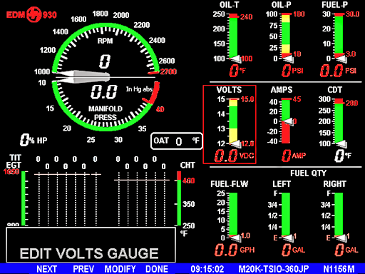

8. Gauge Details Screen
When the MODIFY key is tapped, the Gauge Details Screen will be displayed with an image of the selected gauge and all available values to be modified for the gauge.
The gauge details screen lets you select the minimum and maximum scale, the alarm limits, and the color band positions for normal, warning and alarm ranges. VOLTS will be used as an example how to configure gauge markings.
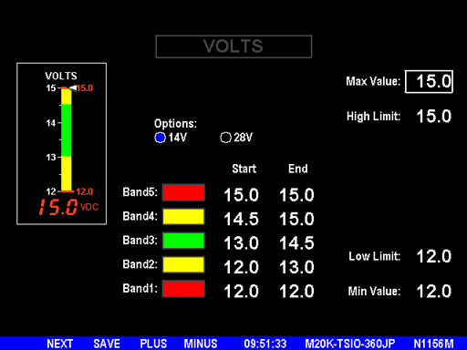

9. Gauge Range and Alarm Limits
To change To change the gauge range, use the NEXT key to select the Max Value or Min Value, and use the PLUS and MINUS keys to adjust the value.
When a gauge contains a RED band in the Band5 position, a High Limit is associated with the gauge. When a gauge has a High Limit, the EDM will display an Alarm message when the gauge value is greater than or equal to the High Limit value. Changing Band5 color from RED to any other color disables the High Limit and the EDM’s High Alarm for the gauge.
When a gauge contains a RED band in the Band1 position, a Low Limit is associated with the gauge. When a gauge has a Low Limit, the EDM will display an Alarm message when the gauge value is less than or equal to the Low Limit value. Changing Band1 color from RED to any other color disables the Low Limit and the EDM’s Low Alarm for the gauge.

10. Color Bands
The color band configuration system enforces the following rules:
- All gauges are configured with five color bands containing from one to five unique colors.
- Color bands are “connected” – the end of one band is connected to (the same value as) the start of the next band, etc.
- If the color band start and end values are equal, the color band will be invisible.
- Two consecutive bands of the same color appear as a single band of that color.
- Changing a color band’s color or start or end value will update the gauge image on this screen.

11. Options
The VOLTS, AMPS and OAT gauge screens have Options selections that allow you to quickly configure the default values associated with the select option. For example, selecting 28V in the VOLTS screen above would load the default values for a 28 volt electrical system. Note: changing the Options value will change multiple band values.
Saving the Data
When you have completed the new configuration for the gauge, tap the SAVE key to save the configuration to the EDM.
Note: This change is immediate when saved.

12. Modifying Aircraft Information
After agreeing to the EDM Configuration Editor Usage Agreement, you will have the opportunity to view a quick slide show describing the basic operation of the EDM Configuration Editor.
If the EDM is a primary instrument configured for a particular aircraft, only values associated with non-primary gauges can be modified. In addition, the aircraft type, aircraft tail number, and engine information will be read-only.

13. Changing Tail Number
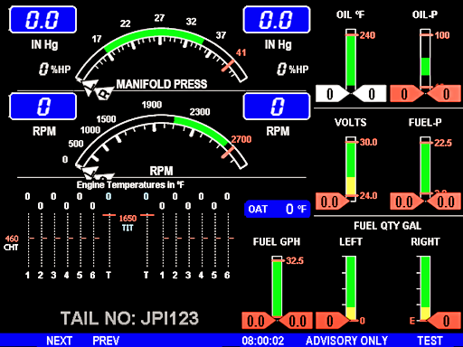
When prompted for TAIL NO: you will notice that the tail number information is displayed in gray text. Hold the NEXT and PREV keys to start editing of the aircraft tail number information. The first character of the tail number will start to flash, indicating that the character will be changed when you tap or hold the UP or DOWN keys
Tip: The EDM uses gray text whenever the value to be modified is “protected.” Protected values are those when require an extra step to prevent accidently modifying the value. Holding the left two keys (NEXT and PREV) unlocks the value to be edited. When you have made the desired changes to the value, hold the two left keys again to store the new value.
If the EDM is configured as a TSO or Advisory Only unit, you will be allow to change nearly all EDM configurable parameters, including the aircraft ID and engine information.

14. Change Number of Engine Cylinders
The CYLS= prompt allows you to change the number of cylinders monitored and displayed by the EDM. Hold the two left keys to start changing the number of cylinders. Tap the PLUS or MINUS keys to increase or decrease the number of cylinders. Acceptable values are 4, 6, 7, 8 or 9. Hold the two left keys to save the modified value.
After changing the CYLS= value, you may also need to change the R-FACTOR value. The R-FACTOR is used to specify the number of pulses per revolution output by your RPM sensor. Available values are 4 – 12.
Changing Engine Temperature Units
The ENG °F / °C prompt allows you to change engine temperature units displayed by the EDM. Hold the two left keys to start changing the number of cylinders. Tap the F or C keys to change to Fahrenheit or Celsius. Hold the two left keys to save the modified value. Note: If the EDM is configured as a PRIMARY unit, you will be not be allowed to modify the Engine Temperature Units except OAT.

15. Changing fuel units
Hold the left two keys to allow changing the FUEL UNITS. Available values are GAL, LBS, LTR, KGS. Hold the left two keys to save changes to FUEL UNITS. Note: Changing FUEL UNITS is only available for TSO and ADVISORY ONLY EDM units.
Note: For PRIMARY units the following changes to the main and aux tank size applies to the fuel totalizer only. For main tank capacities see fuel level section.

16. Changing Main Tank Size
Hold the left two keys to allow changing the MAIN SIZE. Available values are 0.0 to 999.9 gallons, or 0 to 9999 liters, pounds, or kilograms. Hold the left two keys to save changes to MAIN SIZE.
Changing Aux Tank Size
Hold the left two keys to allow changing the AUX SIZE. Available values are 0.0 to 999.9 gallons, or 0 to 9999 liters, pounds, or kilograms. Hold the left two keys to save changes to AUX SIZE.

17. Changing Channels Monitored
When you see the EDIT CHANNELS? prompt, tap the YES key to display the EDM Probe & Sensor Channels screen.
Tap the STEP key to select the next channel to be enabled or disabled. Hold the STEP key to select the previous channel.
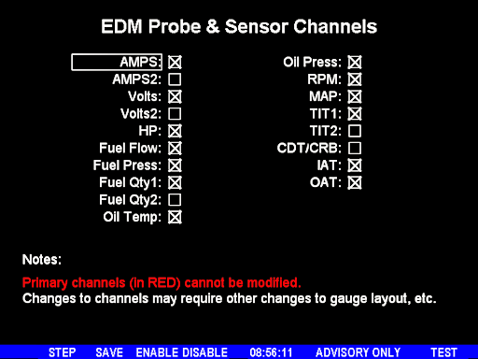
Tap the ENABLE key to mark an “X” to enable the selected channel on the EDM or DISABLE to remove an “X” to disable the selected channel on the EDM.

When all desired changes have been made, tap the SAVE key to exit this screen. If changes have been made on this screen, you will be asked Save Channel Changes? Tap the appropriate key (YES or NO).
Note: If the EDM is configured as a PRIMARY instrument, data channels associated with PRIMARY gauges will be displayed in RED and cannot be modified.

18. Changing Alarm Values
When you see the EDIT ALARMS? prompt, tap the YES key to allow selection of alarm values to be modified.
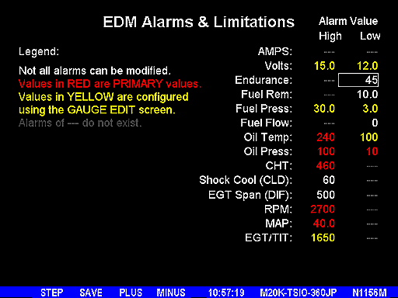

19. EDM Alarms Screen
The EDM Alarms window lets you change some alarm limits. When these values are met or exceeded, a flashing message will be displayed in the EDM's message area.
- You may change any value shown in WHITE.
- Values shown in YELLOW are configured on the gauge displaying the value.
- Values shown in RED are PRIMARY LIMITS and are prohibited from modification.
- Values shown in GRAY do not have an associated alarm.

When you are done changing the alarm limitations press the SAVE key. Alarms associated with gauges displayed on the previous gauge configuration screen, cannot be modified here. Tap PREV to return to the GAUGE EDIT screen to modify values displayed in YELLOW. When used as a primary instrument, government regulations do not allow modification of settings in red.

When you have finished changing the alarms for your aircraft, tap SAVE to move to the next screen.

20. Restoring EDM to a Previous Configuration
When you start the EDM Configuration Editor, you will see a RESTORE FROM USB DRIVE message after the program tutorial screens. You may use this prompt to restore the EDM to a configuration saved during the editing process earlier.
- When you see RESTORE FROM USB DRIVE, install the USB FLASH drive and tap the YES key.
- You will be asked to select the date and time of the saved configuration to be loaded. The EDM will sort the ten most recent backups with the most recent backup file first.
- When you see the point in time that you would like to return to, hold the left two EDM keys until the word SUCCESS EDM RESTORED appears in the message area.
- Follow the prompt to REMOVE THE USB. At this point the EDM will reboot.

21. Restoring EDM to Factory Configuration
Suppose the changes you made are not what you expected. You can restore your EDM to the FACTORY settings for your aircraft by following this procedure:
- Start the EDM Configuration Editor as described on page 2 above.
- Tap NEXT until you see End Config Edits (with YES / NO keys).
- Press and hold both the YES and NO keys until FACTORY RST? is displayed.
- Tap YES key.
- Tap YES key a second time to confirm the reset operation. Warning: All user settings, including K-Factors, and other preferences will be erased. In order to save all pre-set values except fuel tables see USB Configuration Capturing on page 3.
- After the reset operation completes, you will be returned to End Comfig Edits prompt. Tap the YES key.

